Template: Deliverable 4: Wireframes & Feature Plan

CSC425 Fall 2025
Student Name: Landon Webb
Date Submitted: 09/21/25
GitHub REPO URL: https://github.com/CadenOutland/CSC425
Branch Name:d4-Landon-Webb

1. Low-Fidelity Wireframes (Mobile-First)
Insert/export images of your sketches or digital mockups. Each wireframe should be clearly labeled.
• 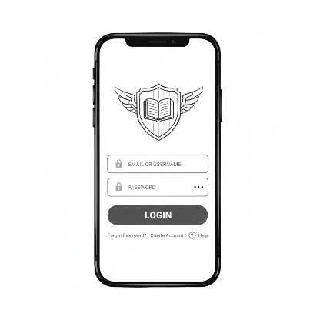
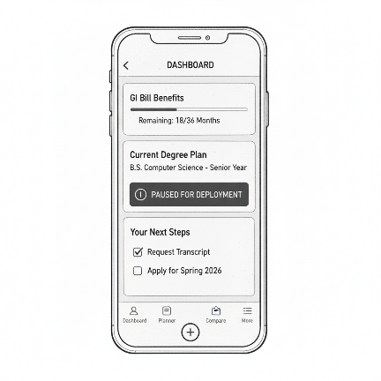
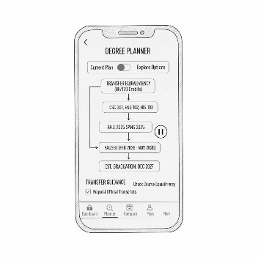

2. Functional Requirements
Provide a bullet-point list of core app features. Be concise but detailed enough to show scope.
• User authentication (sign up, login, logout)
• CRUD operations for academic info: Create a degree plan, read and view current plan , course progress and saved institutions , updating an already existing plan, deleting a degree plan or a saved institution.
• Navigation between core pages (Login → Dashboard → Features)
• Data persistence with backend integration
• Error handling & input validation
• API integrations: to retrieve and display GI bill status and maybe eligibility and integration with transfer equivalency .
• A per person degree mapping the ability to create and modify a degree plan that can let you pause for military relocations and deployments.
• A more support page having a checklist for common tasks and guides and resources for navigating VA.

3. User Stories
Provide 3–5 detailed user stories following the required format.

As an active-duty service member, I need to plan my academic path so that it can handle unexpected deployments or transfers, so that I can take a break without losing the progress I've made on my degree.

As a veteran student, I want a picture of how my military training and previous classes count toward my degree, so that I don't waste time and money r classes I've already earned the proper credits for.

As someone considering going back to school, I want to easily compare the GI Bill benefits and costs of different colleges, so that I can pick the one that gives me the most value for my education benefits.

As a student transferring to a new school, I want a checklist of all the forms and deadlines I need to complete, so that the transfer process feels less stressful and I don't forget any steps.

4. User Journey Flow
1.)A user opens the app and then signs up for an account . Then they are prompted to give their information possibly including their veteran status and if applicable college transcripts .
2.) The user is then sent to the dashboard where they can start a new degree plan
3.) the user will select a desired major and searches for a possible institution . The app displays info on that schools GI bill status and general cost.
4.) The user will input courses from military training and possibly previous universities then the app will search for transfer equivalency data to show which credits will be accepted .
5.) The user will see their custom degree path including things like remaining credits and a graduation estimate
6.) The user will be able to pause a plan if deployment occurs .
7.) The user can login and then proceed to resume their plan / academic journey.

(Optional Note)
This is my individual submission. The team will review all submissions and agree on a final version for project continuation.

